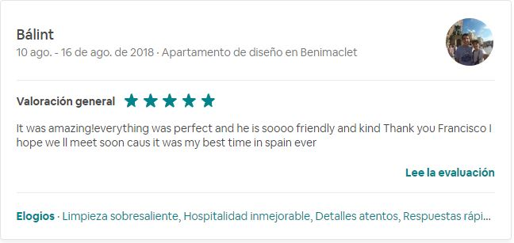

Evaluación pública

It was amazing! everything was perfect and he is soooo friendly and kind. Thank you Francisco I hope we'll meet soon cause it was my best time in Spain ever

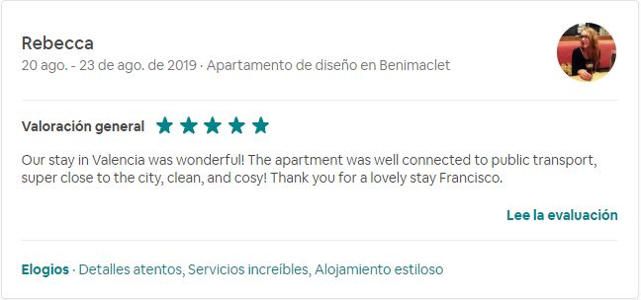

Evaluación pública

Our stay in Valencia was wonderful! The apartment was well connected to public transport, super close to the city, clean, and cosy! Thank you for a lovely stay Francisco.

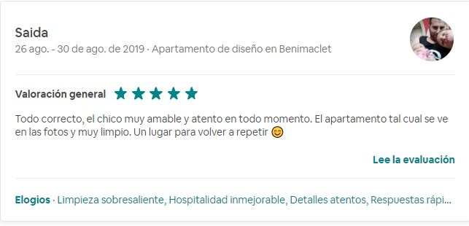

Evaluación pública

Todo correcto, el chico muy amable y atento en todo momento. El apartamento tal cual se ve en las fotos y muy limpio. Un lugar para volver a repetir 😊

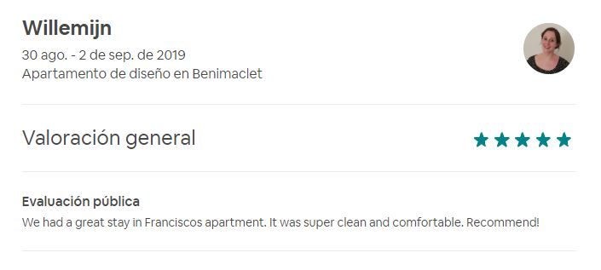

Evaluación pública

We had a great stay in Francisco's apartment. It was super clean and comfortable. Recommended!

